**IS 823 - Individual Class Project**

**Section 2**

**Prepared by: Tanzina Sultana**

**Date: 12/9/19**

# Introduction

The presented database on section 1 is interrelated with one another. The process is representing relationships among all the parties. Parent table include fundamental information related to the category of the table. There is also some linking table those are helping to connect two main component table at the same time remove the possibility of data redundancy of those table.

## Mission Statement

Mission Stamen is where this organization wants to reach in a short time. In our given scenario the mission of this organization. The mission statement is providing the best service to each of their customers within a very fast moment possible with low price.

***“Emphatic, available, high quality, price efficient healthcare to the community; endorsing healthiness; edify healthcare professionals along with contribute in proper medical research”.***

## Scenario

This scenario can take by service providing organization. Because the category of the database are not related with any money-making function, so the determination of this category of organization is service such as clinic or large hospital. Because in the database represents individual data of main parties. There are some relationships between these parties. These relationships represent connection between two or more parties in the database which provides the direction of working sequence from one party to another party. Though a big hospital has a large volume of data and most of data are from same set and can be accessed by all the different parties available in the hospital system. This situation can make a lot of data redundancy in the database to resolve this challenge. In this new created database linking table would make a relationship between two different table sharing same data. From the given database the scenario of the organization comes up is that, it is a hospital where physicians have their own chambers, their officers are situated in different locations of the Hospital building. Office of physician are divided according to their specialization. So do for the nurses. Nurses have their own Identification number which is tied up with the physician also office number of physicians have a direct connection with the nurse ID cause for scheduling their work with respective physician. Patient have their own database including all their personal information this table is tied up with the prescription table for their medical details. Prescription table is also tied up with the consultation table and the Pharmacy table, where all information related to the pharmacy are stored. The Prescription table also connect the Pres-drug table this table holds the date and time for the medicine started. There is one connecting table having information about the allergy history of the patient the actions taken against this situation is also included in this table. Junction tables are mostly used for mitigating redundancy and connection two different tables.

This database system is more appropriate for big Hospital. Since small hospital or area based clinic doesn’t have such variations suppose the consultant and physicians are at the same place along with the availability of pharmacy at the hospital compound. This type of system are more accurate with the large hospital where service providing process are accumulated with the pharmacy and drug storage operations. Such kind of database are required for where different parties are using same set of data and their operations.

**Techniques**

Techniques that can be used to collect such information in mainly depending on the on-job interview service for physician and nurse and for patient direct interview would be the result of collecting information.

* **Interviews**: Patient data collection must require the interview of the present patient. For previous patient case files works as the data input in the database because those previous patient file has almost all requires data for the patients.
* **Observation**: Collecting Consultant or medical technician's data, Nurses details and office related data observation is the best way to use. Because most of their tasks are repetitive and mostly the same for all the patients. This observation also provide the scope to find out the relationship among those departments and external relationships with other departments as well.
* **Questioning**: Collecting Physician data is another most important key for this database. Physician data can be collected by questioning them. Certain terms of question set along with some standby questions will be required for the questioning process.
* **Questionnaire**: Questionnaire process might follow for collecting information about the category of drugs are mostly used in treatment process. The available drug their ingredients and their reaction rate on human body mostly identified by questioner process. This data collection process also provides the success rate of the system.

**Context data flow diagram**

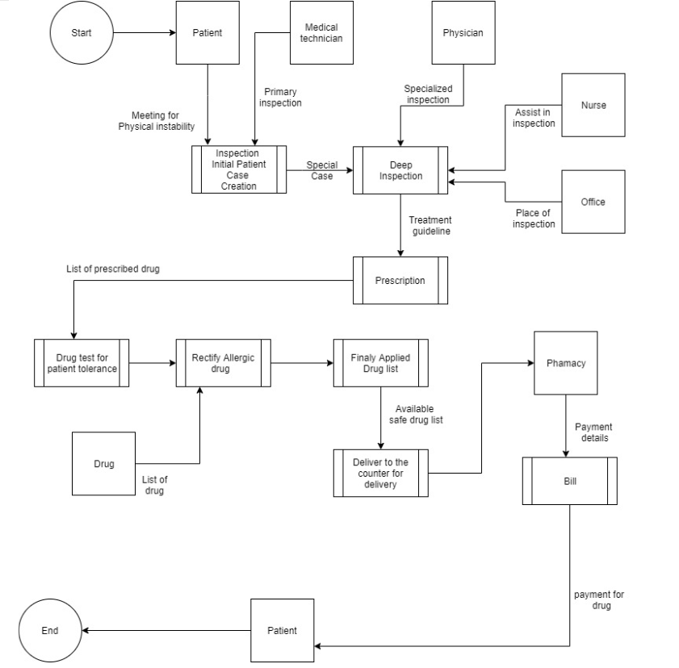

# Final Project BPMN

